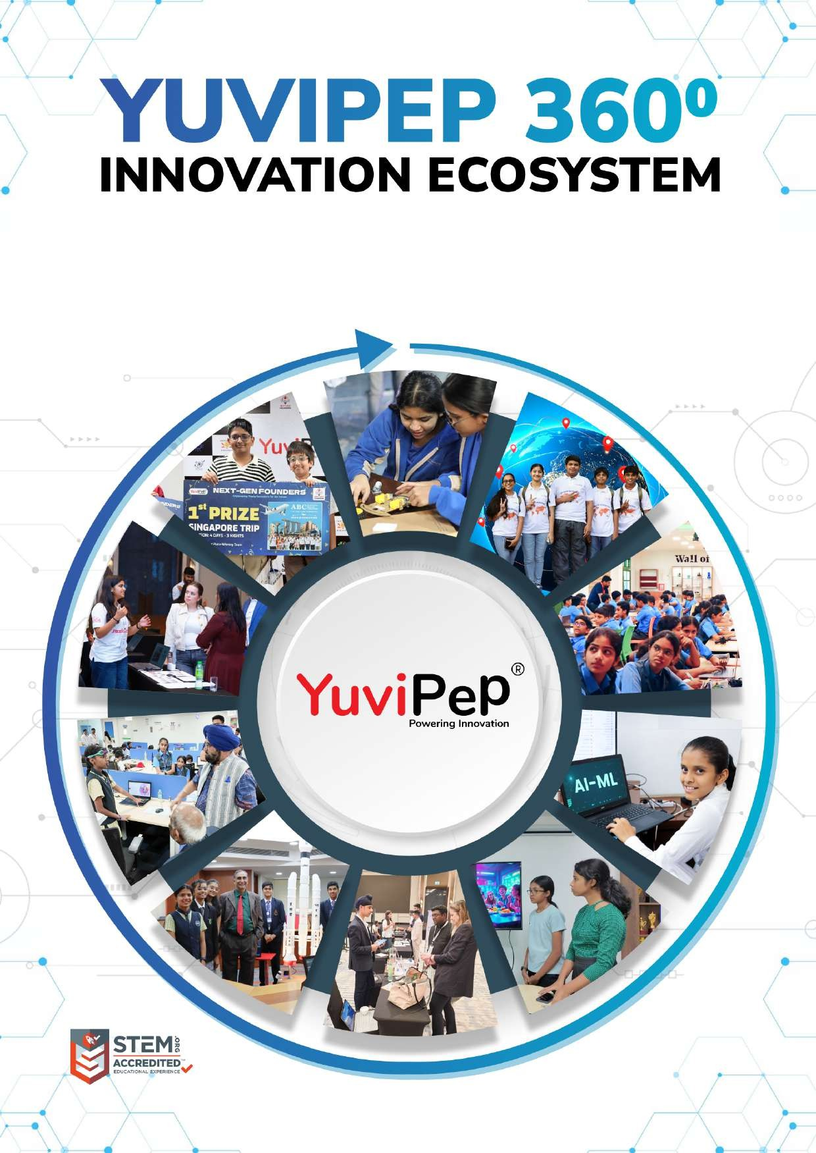
- 1 -
Copyright 2026 YuviPep© All Rights Reserved School Name

EmpowerED - IBC
School Name

About YuviPep 360° Innovation Ecosystem

Building India’s first School-to-Startup Innovation Pipeline
The 360° Innovation Ecosystem is a full-stack platform embedded within academic environments. It creates a structured pathway in which students move from foundational innovation learning to advanced technology application, industry immersion, prototype development, incubation, and investor readiness.
YuviPep 360° Innovation Ecosystem is a future-focused, integrated platform designed to transform how students learn, create and lead. It operates as a comprehensive, interconnected framework rather than a standalone programme, strengthening academic environments, enhancing student outcomes and creating a clear pathway from learning to leadership.
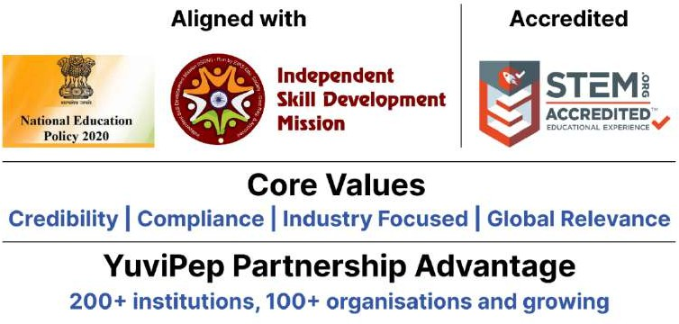
The YuviPep 360° Advantage
Built on ten strategic pillars, the YuviPep 360° Advantage creates a powerful ecosystem that connects learning with industry, innovation and global opportunity.
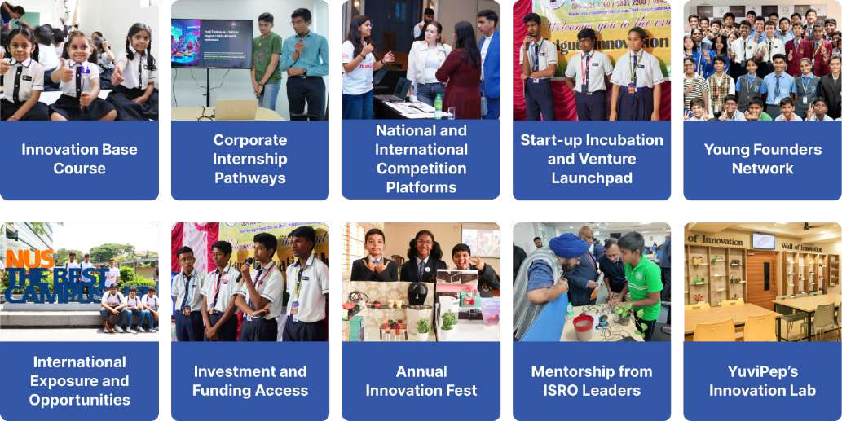

Innovation Base Course (IBC)

YuviPep’s Flagship Innovation Curriculum
The Innovation Base Course is a structured, hands-on STEAM learning platform integrated into the school curriculum. Students explore Practical Science, Design Thinking, Coding, Mechatronics, Automation, IoT, AI and Robotics through guided, application-based learning.
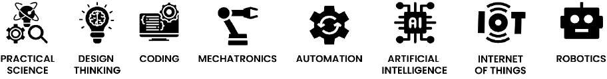
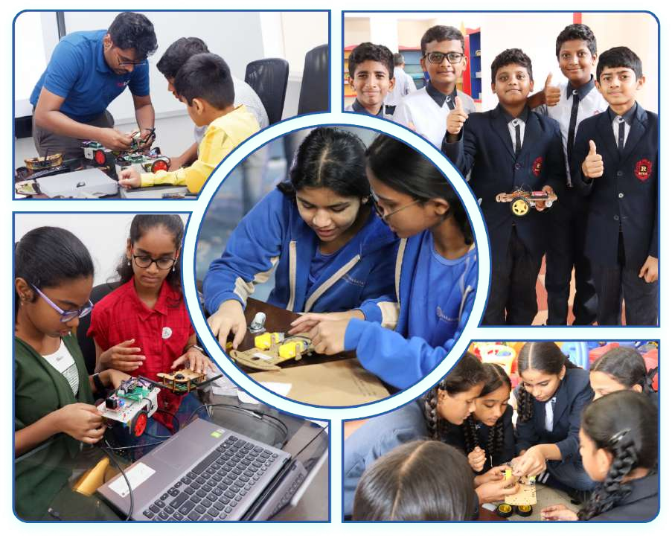

Innovation Pipeline
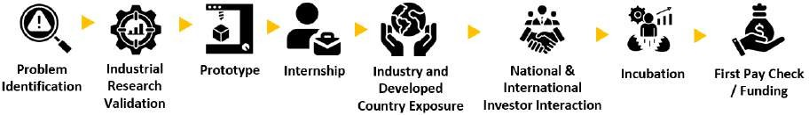

Gateway to Global Opportunities
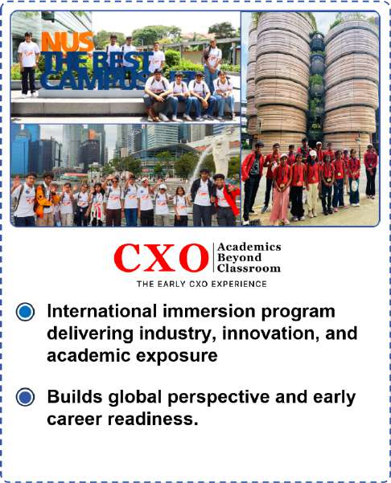
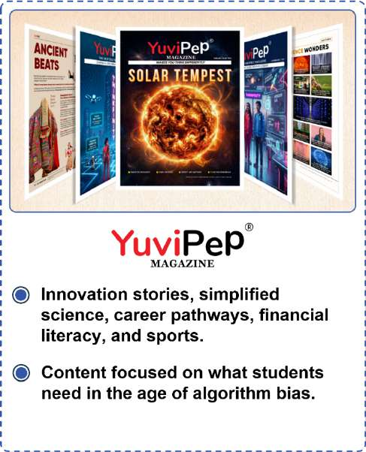

Mentorship, Recognition and Appreciation
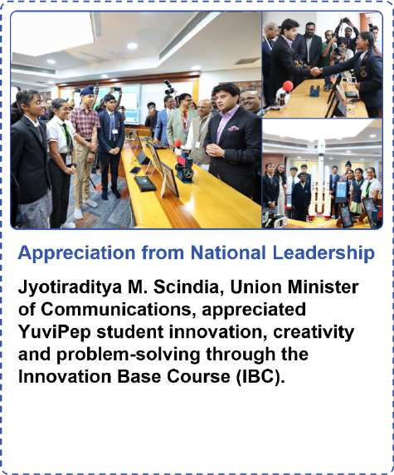


YuviPep’s Knowledge Portals
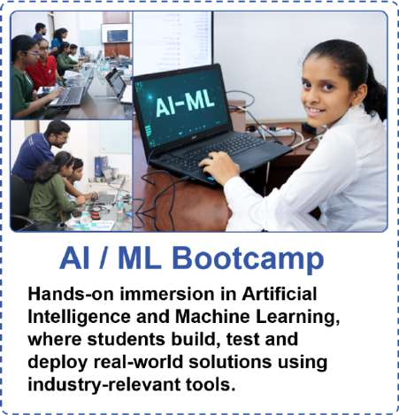
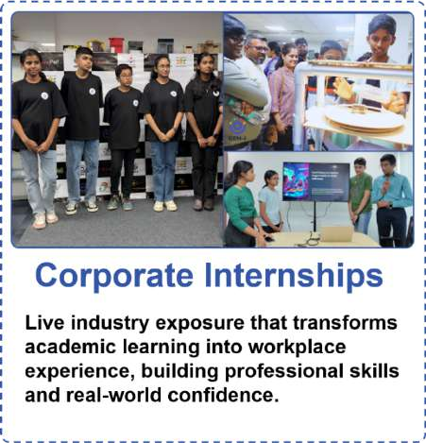
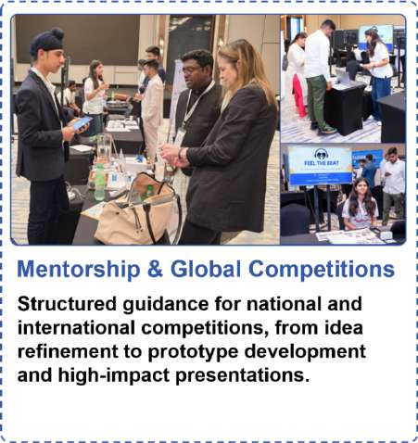
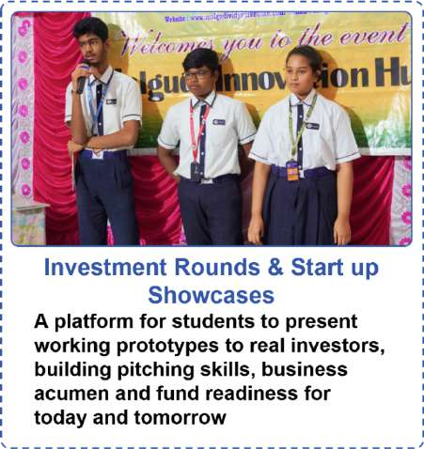
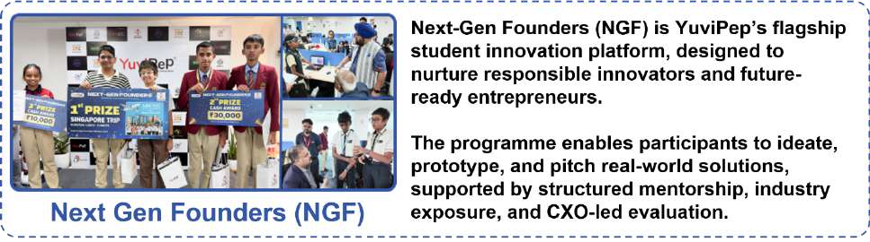

What Makes YuviPep the Right Choice?

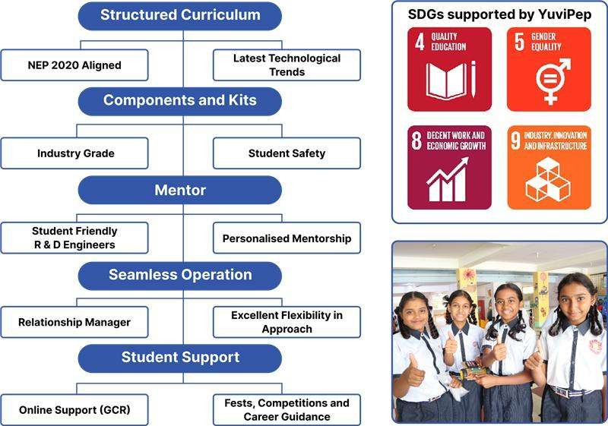
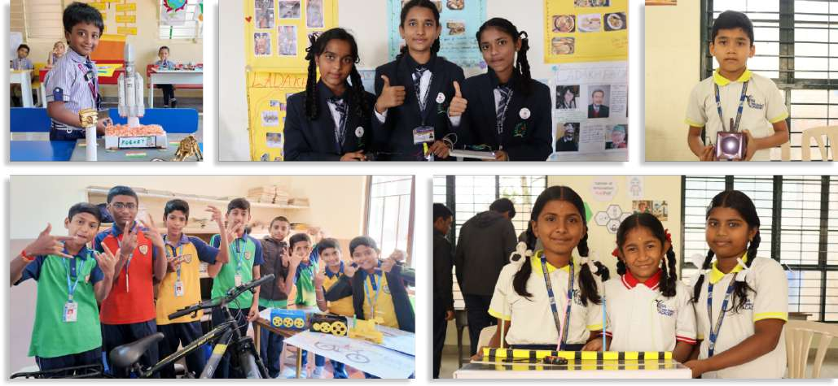

Competitions that YuviPep Students Won

YuviPep Students Shine at Prayag 2025
YuviPep students showcased outstanding innovation and problem-solving skills at Prayag 2025, organised by the Adi Shankara Institute of Science and Technology in Angamaly on 18th and 19th September 2025.
- Cryptic Codex (18th September) – First Prize:
Team Members: Jayden Liju Daurav, B. Vishnutejass, Unnikrishnan Pradeep, Sakaria Sunny
- IdeaǪuest (19th September)
  - Team 1: Josua Baju (XII), Adheen P. Wilson (XII), Chris Joseph Joby (XII) – Second Prize
  - Team 2: Michael Baju (XI), Janet Kallarackal (XI) – Third Prize
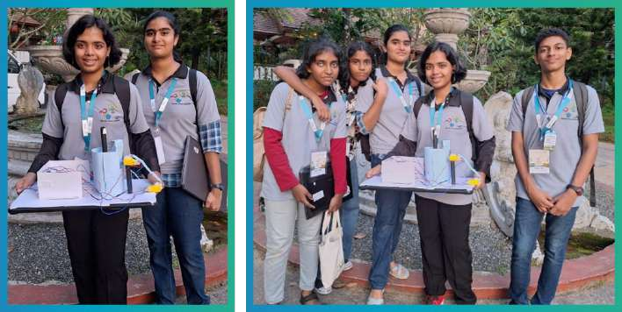

Record-Breaking Win at KISA Robotics Competition 2025–26
YuviPep students from Swargarani School and Vidya Jyoti School showcased exceptional talent at the KISA Robotics Competition – Regional Level 2025–26, competing against 73 schools and over 260 participants.

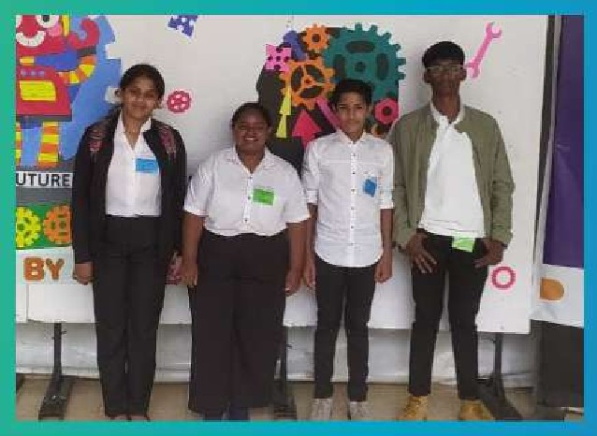

Swargarani School
Pranav B. S. and Avani M. Raghavendra won First Prize

Vidya Jyoti School
Students secured Second Prize

YuviPep Students Excel at ISF and Global Innovation Summit
As part of the 100K Initiative, which saw thousands of students from Grades 1–10 and above submit ideas through the Ideathon portal, four YuviPep students were among the finalists at the International Startup Festival (ISF) Hyderabad.
From this group, Adhya K.V (Prudence International School) and Jaswin Baweja (Sir Mutha School) were shortlisted for the Global Innovation Summit C Retreat – Dubai 2026.
At the world stage, over 70 Junicorn teams from India and the UAE pitched at the Manipal Academy of Higher Education (MAHE), presenting directly to Idea Seed Angels and international VCs.
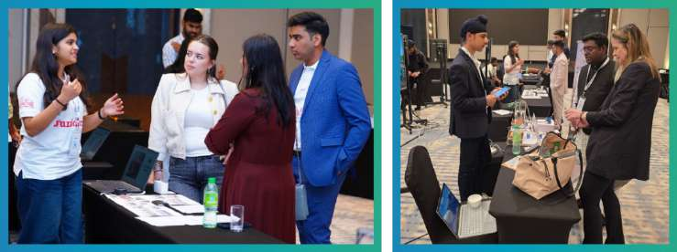

YuviPep’s Growing Impact Across India
A rapidly expanding national presence driving innovation, skill development and future-ready learning across institutions in India.
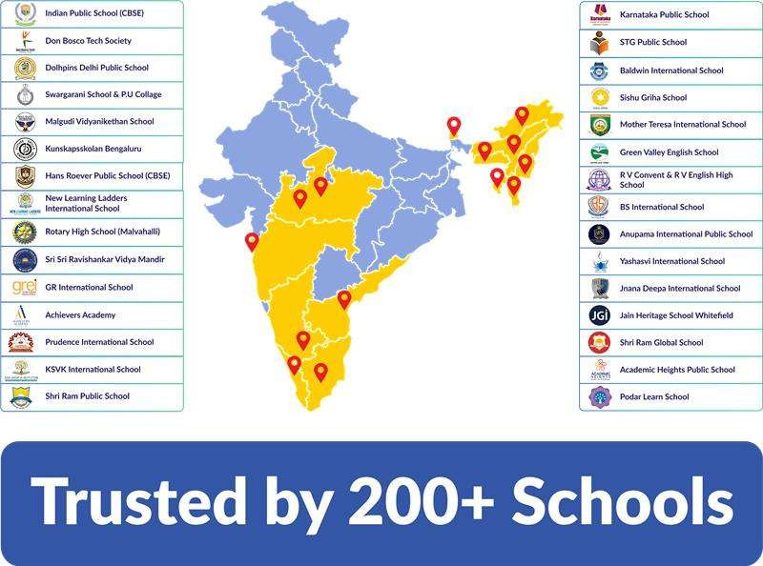

Innovation Base Course (IBC)

Curriculum Overview
A progressive hands-on STEM programme where students design, build, and present real technology systems across robotics, AI, IoT, and digital fabrication. The following is a sample representation of the IBC curriculum, providing a clear view of what students will learn and experience through the programme.

Grade 6

Topic Name | Activities Involved | Learning Outcomes
Park Entrance Light Circuit | - Builds the entrance arch light  circuit.  - Connects a battery, switch, resistor, and LED.  - Tests ON and OFF operation. | - Understands a complete electric  circuit.  - Learns the role of a switch and a resistor.  - Gains confidence in basic wiring.
Steadiness Game – Conductors C Insulators | - Builds a wire loop game.  - Tests materials such as metal, plastic, rubber, and wood.  - Observes LED response on contact. | - Identifies conductors and insulators.  - Understands material properties.  - Practices testing and observation.
Cafeteria Buzzers C Switches | - Builds a push-button buzzer  circuit.  - Tests a touch sensor alarm.  - Explores real-life alert systems. | - Learns how switches control circuits.  - Understands buzzer and alarm use.  - Connects electronics to daily life.
Water Level Indicator | - Builds a 3-level water sensor.  - Observes LEDs turning on as water rises.  - Discusses tank monitoring systems. | - Understands simple sensing circuits.  - Learns how electricity reacts to water contact.  - Relates sensors to real applications.
Optics Corner – Light C Refraction | - Uses a torch, prism, and glass  slab.  - Observes dispersion and refraction.  - Experiments with total internal reflection. | - Understands the behaviour of light.  - Learns basic optics concepts.  - Develops scientific observation skills.
Colour Booth – Resistors C RGB Control | - Tests LEDs with and without  resistors.  - Controls an RGB LED using potentiometers.  - Observes colour mixing. | - Learns why resistors are important.  - Understands RGB colour mixing.  - Controls brightness and colour safely.
Automatic Street Lights (LDR) | - Builds an LDR-based light  circuit.  - Tests the light ON and OFF in dark and bright conditions.  - Connects lamp posts along the path. | - Understands light-dependent  resistors.  - Learns automatic control systems.  - Sees electronics used in cities.

Solar Park – Solar Energy Basics | - Uses a solar panel with torch or  sunlight.  - Measures brightness at different angles.  - Lights an LED using solar power. | - Understands solar energy basics.  - Learns the effect of angle and intensity.  - Connects renewable energy to electronics.
Energy Storage with Capacitors | - Charges a capacitor using a  solar panel.  - Observes the LED staying on after source removal.  - Uses an LED bar to show stored charge. | - Learns basic energy storage  concepts.  - Understands capacitors in simple terms.  - Connects storage to real devices.
Series vs Parallel Circuits | - Builds series and parallel LED  circuits.  - Removes one LED to compare behaviour.  - Observes brightness differences. | - Understands circuit types.  - Learns fault tolerance concepts.  - Applies knowledge to street lighting.

Grades 7 and 8

Topic Name | Activities Involved | Learning Outcomes
LED Light Lab | - Builds a simple LED circuit.  - Turns the circuit on and off using a rocker switch.  - Fixes the light circuit in the model setup. | - Understands what an LED is and how  it works.  - Identifies the two terminals of an LED and connects it correctly.  - Understands open and closed circuits.  - Learns how a switch controls a circuit.  - Builds a basic working light circuit.
Brightness Builders | - Builds an LED circuit with a resistor.  - Uses a potentiometer to change the brightness.  - Tests and compares dim and bright light levels. | - Understands the role of resistors in a circuit.  - Learns that a resistor protects an LED by controlling current.  - Gets introduced to resistor colour bands.  - Observes how changing resistance affects brightness.  - Understands the use of a variable resistor.
Conductors in Action | - Tests different materials in a  simple circuit.  - Checks which materials allow current to pass.  - Performs a basic continuity test. | - Understands the difference between  conductors and insulators.  - Identifies materials that allow electricity and those that block it.  - Learns the idea of continuity in a circuit.  - Connects the concept to real-life wires, plugs, and coverings.  - Builds observation and testing skills.

Meter and Measure | - Measures battery voltage using a  multimeter.  - Measures resistance of components.  - Compares a new battery and a used battery. | - Understands voltage as the electrical  push in a circuit.  - Learns to measure voltage safely using a multimeter.  - Understands resistance as something that controls current flow.  - Learns to measure the resistance of basic components.  - Compares battery strength using readings.
Series and Parallel Explorer | - Builds two LEDs in series.  - Builds two LEDs in parallel.  - Compares brightness and circuit behaviour in both setups. | - Understands the difference between  series and parallel circuits.  - Observes how current behaves in each type of connection.  - Compares LED brightness in both circuits.  - Learns what happens if one-part stops working in series and in parallel.  - Connects the idea to real-life wiring systems.
Smart Alerts and Alarms | - Builds a simple buzzer circuit.  - Makes a push-button doorbell setup.  - Builds a water level buzzer indicator. | - Understands how a buzzer works in a  circuit.  - Learns how a push button can be used to make a doorbell.  - Sees how circuits can be used as alert systems.  - Understands basic water level detection using conductivity.  - Relates the build to real-life alarm systems.
Relay and Pump Control | - Connects a relay with a water  pump.  - Observes how a small control signal switches the pump.  - Uses the setup to move water in the model. | - Understands a relay as an  electrically controlled switch.  - Learns how low-power control can operate higher-power devices.  - Observes how pumps can be controlled using circuits.  - Understands simple automation in water systems.  - Recognises real-life use of relays in homes and machines.
Inside Embedded Systems | - Gets introduced to a  microcontroller.  - Programs an LED to blink.  - Observes how code controls hardware. | - Understands what an embedded  system is.  - Learns the role of a microcontroller in electronic products.  - Observes a simple program controlling an LED.  - Understands that hardware and software work together.

Digital Input Basics | - Connects a push button as an  input.  - Reads the button press using the microcontroller.  - Triggers an output or message from the input. | - Understands digital input as on or  off, or high or low signals.  - Learns how a push button sends input to a microcontroller.  - Observes how the board responds to button presses.  - Understands basic interaction between user input and system response.
Analog Input Basics | - Connects an LDR to the  microcontroller.  - Reads changing light levels.  - Uses the reading to control light behaviour. | - Understands the difference between  digital and analog input.  - Learns how an LDR senses light intensity.  - Observes how light levels change sensor values.  - Connects the idea to automatic lighting systems.

Grades 9 and 10

Topic Name | Activities Involved | Learning Outcomes
Light It Up! — Circuits C Conductivity | - Builds a simple LED circuit using  a battery, wires, and an LED.  - Demonstrates turning the circuit on and off using a manual switch.  - Tests various materials such as a metal coin, plastic ruler, wooden stick, aluminium foil, and rubber eraser to classify them as conductive or non-  conductive. | - Understands the basic components  of an electrical circuit, such as a battery, a wire, an LED, and a switch.  - Explains the role of a switch in controlling current flow.  - Differentiates between conductive and non-conductive materials.
Dim C Buzz — Controlling Circuits with Resistors | - Connects a resistor in series  with an LED and observes the change in brightness compared to without a resistor.  - Swaps different resistor values such as 330Ω, 1kΩ, and 10kΩ and compares brightness levels.  - Replaces the LED with a buzzer and uses a resistor to control the sound intensity. | - Understands the function of a  resistor in limiting current flow in a circuit.  - Observes and explains how resistor value affects LED brightness.  - Explores how resistors influence sound output in a buzzer circuit.  - Reads and interprets basic resistor values or colour codes.
Turn the Knob — Variable Resistors in Circuits | - Connects a potentiometer in  series with an LED and rotates the knob to observe continuous brightness changes.  - Replaces the LED with a buzzer and uses the potentiometer to vary the sound intensity. | - Understands how a potentiometer  works as a variable resistor.  - Observes and explains continuous control of current using a potentiometer.  - Distinguishes between fixed and variable resistors and their applications.

- Develops an understanding of analog
control in circuits.
Find the Fault — Circuit Diagnosis with a Multimeter | - Gets introduced to the  multimeter, its parts, settings, and safe usage.  - Measures voltage across components such as battery, LED, and resistor.  - Uses continuity mode to identify broken wires or faulty connections.  - Introduces faults and diagnoses them using the multimeter. | - Identifies the key functions of a  multimeter, such as voltage, current, resistance, and continuity.  - Safely operates a multimeter in a circuit.  - Uses continuity and voltage readings to locate faults in a circuit.  - Develops systematic troubleshooting skills.
Series Break Test! | - Builds a series circuit with  multiple LEDs and a battery.  - Disconnects one component and observes the effect on the entire circuit.  - Uses a multimeter to locate the exact point of failure.  - Compares behaviour with a parallel circuit as a preview. | - Understands that a single break in a  series circuit stops all current flow.  - Uses observation and measurement to locate faults.  - Explains why series circuits are used in certain applications.
Touch C Buzz — Sensor-Based Sound Circuits | - Builds a simple doorbell circuit  using a push button and buzzer.  - Assembles a touch sensor buzzer circuit using a touch-sensitive module. | - Understands how a push button  works as a momentary switch.  - Explains the working principle of a basic touch sensor.  - Builds and tests a functional doorbell and touch-activated buzzer circuit.  - Identifies input and output components in a circuit.
Splitting Light — Prisms, Rainbows C Dispersion | - Passes white light through a glass prism and observes  spectrum formation. | - Understands that white light is composed of multiple colours.  - Explains dispersion and how different wavelengths refract at different angles.  - Identifies and orders the colours of the visible spectrum.
Series vs. Parallel  — LEDs C Smart Street Lighting | - Builds a series circuit with an  LDR and LED to understand its working.  - Builds a parallel circuit with an LDR, LED, and resistor.  - Creates an automatic street light model. | - Distinguishes between series and  parallel circuits in terms of brightness and reliability.  - Explains why parallel circuits are preferred in real-life lighting systems.  - Builds and tests a light-dependent automatic circuit.  - Understands how LDRs function as sensors.
Sun Power — Solar Panels C Optimal Angle Testing | - Connects a solar panel to an  LED and observes it lighting up under light. | - Understands how solar panels  convert light into electrical energy.  - Observes how angle affects power output.

- 12 -

 | - Varies the angle of the panel and  measures output using a multimeter.  - Records readings and compares performance at different angles.  - Discusses the concept of optimal tilt angle. | - Identifies the optimal angle for  maximum efficiency.
Power from Motion  — Exploring Dynamo | - Demonstrates a hand-crank  dynamo.  - Connects it to an LED and observes light generation.  - Varies speed and observes changes in brightness. | - Understands electromagnetic  induction.  - Explains how mechanical energy converts into electrical energy.  - Observes the relationship between motion and electrical output.

Inside the YuviPep 360° Programme

Programme Aligned with NCERT and NEP Guidelines
The programme is thoughtfully structured to complement the NCERT curriculum and the vision of the National Education Policy (NEP) by integrating conceptual learning with hands-on application. Students explore core scientific and mathematical principles through practical experiments, design-thinking activities, and real-world problem-solving. This approach strengthens classroom learning while encouraging curiosity, creativity, and interdisciplinary thinking, ensuring that students develop strong academic understanding alongside innovation-driven skills for the future.

Enhancing English Language and Communication Skills
Through regular presentations, project demonstrations and the annual Innovation Fest, students gain valuable exposure to public speaking and communication. They learn to confidently explain their ideas, present prototypes and engage in discussions with mentors, teachers and peers. This interactive environment naturally enhances their English language proficiency, articulation and storytelling abilities, enabling them to communicate complex ideas clearly while building confidence on public platforms.

Life Skills Development through the IBC Programme

Foundation Level | Introduces students to essential life skills through collaborative activities, communication challenges and structured problem-solving exercises. These experiences develop teamwork, clear expression, analytical thinking and a positive learning mindset.
Applied Level | Builds personal effectiveness and social awareness through leadership opportunities, time-management exercises and real-life conflict-resolution scenarios. Students also practise reflection to strengthen planning, empathy, self-awareness and responsible decision-making.
Advanced Level | Prepares students with behavioural and professional competencies through ethical discussions, collaborative project management, public speaking and stress management awareness. This stage develops leadership presence, resilience, digital responsibility and effective teamwork.

EmpowerED Teachers Training Programme
EmpowerED is a structured teacher training and enablement programme designed to equip school educators with the knowledge, confidence, and practical skills required to effectively deliver the STEM curriculum in the classroom.
The programme follows a progressive monthly training model, where teachers are trained in advance on the concepts, projects, and delivery approach for the upcoming month. This ensures that educators are fully prepared to guide students through hands-on, project-based learning experiences with clarity and confidence.
Teachers participate in a dedicated training session focused on the specific topics. Following the session, teachers implement the learning in the classroom, facilitating student engagement, project execution, and conceptual understanding. This cycle continues throughout the programme, ensuring consistent support, alignment, and high-quality delivery.

Programme Structure and Timeline
EmpowerED is designed as a structured teacher enablement journey that is directly aligned with the Innovation Base Course curriculum.

Particulars | Description
Training Frequency | Ǫuarterly two days
Number of Students | 1000
Number of Projects | 16
Grades | 6 to 10
Format | Live, interactive practical sessions
Execution Model | Hands-on STEM learning and teacher enablement
Each session is strategically scheduled before the start of every academic cycle, ensuring teachers are fully prepared to deliver that month’s curriculum with confidence and clarity.

Execution Model (How It Works)
The programme follows a predictive training model, ensuring teachers always stay one step ahead.

Step 1: In-Person Teacher Training | Teachers are trained on STEM concepts, experiments, and project builds through structured practical sessions.
Step 2: Classroom Delivery | Teachers implement the learning using structured kits, materials, and guided methodologies.
Step 3: Continuous Support | Ongoing assistance ensures smooth execution, problem-solving, and clarity at every stage.
Step 4: Progressive Advancement | Each session will be built on the previous one, creating a seamless and structured teaching-learning flow.
This cycle ensures consistent quality, zero disruption, and high engagement in every classroom.

Key Objectives and Outcomes
- Build teacher confidence in delivering STEM education
- Enable hands-on, project-based classroom learning
- Ensure consistent and high-quality programme execution
- Develop practical teaching capability in emerging technologies
- Foster a culture of innovation, curiosity, and problem-solving
- Create self-sufficient schools with strong internal teaching capability

Deliverables and Support

Deliverable | Details
Teacher Training Sessions | Ǫuarterly 2-days structured in-person training sessions
Curriculum Mapping | Session-wise alignment with Innovation Base Course topics
Teaching Resources | Study materials, workbooks, and instructional guides
Classroom Support | Guidance for experiments, builds, and project execution
Assessment Framework | Structured evaluation and revision support
Project Assistance | Support in guiding student innovation and builds
Certification | Programme completion certification for teachers
Dedicated Support | Account management for seamless coordination

Teacher Benefits and Impact
- Gain practical exposure to real-world STEM concepts
- Develop confidence in handling hands-on learning environments
- Transition from traditional teaching to experiential facilitation
- Enhance professional capability in technology-integrated education
- Become innovation leaders within the school ecosystem
- Reduce dependency on external trainers over time

Student Impact (Indirect Outcomes)
- More engaging and interactive classroom experiences
- Stronger concept clarity through practical application
- Increased interest in science, technology, and innovation
- Development of critical thinking and problem-solving skills
- Exposure to real-world applications and future-ready skills
- Improved participation, curiosity, and learning outcomes

Investment and Deliverables

Pricing Structure - EmpowerED

Programme Name | Programme Price
EmpowerED Teachers Training Programme | Rs. 8,00,000/- net (Including GST)
EmpowerED Programme (Without Training) | Rs. 5,50,000/- net (Including GST)
Number of Teachers Training | 2
Training Frequency | Ǫuarterly 2-days
Note: The exclusive price applies only to School Name. Any changes to the number of teachers or the operations plan may affect pricing.

Terms and Conditions
- Training sessions will be conducted as per the agreed schedule
- Schools are expected to ensure teacher participation for all sessions
- Programme execution is aligned with the Innovation Base Course timeline
- Any changes in scope, scale, or delivery structure may impact commercials
- All programme content and materials remain the intellectual property of the organisation
- Unauthorised use, reproduction, or distribution is strictly prohibited
By investing in teachers, the programme ensures long-term impact, scalability, and sustained excellence in STEM learning.

Payment Terms and Options

Advance Payment | An advance payment is collected while signing the MoU.
Payment Options | Payments can be made through NEFT, cheques, Credit cards, or Debit cards.

Disclaimer: This document and its contents are the exclusive property of YuviPep Education Private Limited and are strictly confidential. No part of it may be disclosed, copied, reproduced, distributed, or used without prior written consent from YuviPep Education Private Limited. Unauthorised use or disclosure may lead to legal action.

info@yuvipep.com www.yuvipep.com
Contact Details
+91 99870 04991
YuviPep Education Pvt Ltd,
Neil Rao Towers, Plot #117, Rd Number #3, EPIP Phase I, Whitefield,
Bengaluru, India

